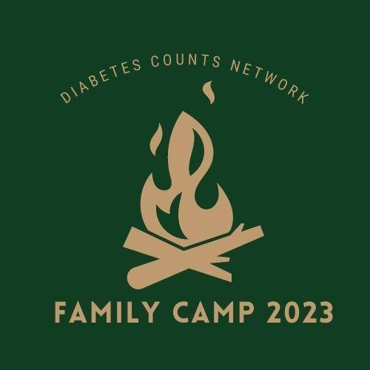

Dear Campers,

It is finally here! Family Camp 2023 has been a monumental effort because of some major changes that have developed in the last year. We are excited about the new potential and are certain that you will love what we have planned! With that, we also want to express our appreciation for your patience and understanding as we navigate a new experience for Family Camp. Thank you! The Board of Diabetes Counts Network is looking forward to hosting your family for a weekend of reconnecting and bonding with fellow T1 families in a new location. This year, our camp is at Grand Mesa Methodist Camp and our theme is “Back to Nature”! We want to return to our roots and focus on the great outdoors and that ol’ fashion feeling of quality family time. We won’t have archery or a ropes course but will have a ton of other great things planned!

One benefit of family camp is in recognizing that not all families who have a member with Type 1 Diabetes are the same. We hope you will help us share those differences and celebrate them as learning opportunities. At camp you will also see the similarities of being a Type 1 family, we hope you will find encouragement in these similarities.

We want to make sure the camp is a success, we ask you to please read carefully about the following changes to the camp:

- Camp is at a NEW LOCATION of Grand Mesa Methodist Camp - this is located at 26269 Old Grand Mesa Rd, Cedaredge, CO 81413. Our accommodations are more rustic than in the past. Cabins will be first come first serve based on availability. Families may be asked to share a cabin with one another. We have cabins for 18 families but are welcoming those who want to camp in tents or dry camp in campers. Please let us know if you want this option as indicated in the registration packet.

- The menu for camp meals has been curated by Community Hospital Chefs, all food that is served will be brought in. Families will be expected to help with dish duty and kitchen clean-up for each meal served.

- We are hosting a TALENT SHOW on Saturday evening. If you have a work of art you want to showcase or a special performable talent you want to share, please have this prepared before camp and be ready to perform or display your talent.

- There is an open body of water on the camp property. Grand Mesa Methodist Camp and Diabetes Counts Network are not liable for campers on the water. NO SWIMMING IS ALLOWED and all children must be supervised by a parent around/on the lake. Diabetes Counts Network will not be providing lifeguards or supervision. Families are encouraged to bring fishing gear.

- This camp is for families with at least one member who is a Type 1 Diabetic (T1D). Please be aware the Diabetes Counts Board and volunteers are not able to provide round-the-clock health care for family members with T1D. This is the responsibility of the parents/guardians in each family. There is emergency medical care available to you and first aid can be provided if need be.

- **PLEASE NOTE** If you plan to check-in later than 6pm, let us know beforehand to ensure meals are saved.

There are many others who will be volunteering their time to make this camp a success and we hope you will take the time to thank them for their assistance. Thank you so much for your interest in our camp, we look forward to seeing you this summer! A final schedule and camp menu will be emailed to all registered families one week prior to camp

Sincerely,

Diabetes Counts Network Board of Directors

2023 Speaker Profiles

Brian Dalrymple

Brian was born in Tacoma Park, Maryland on January 15th, 1972 and was diagnosed with Type 1 Diabetes on July 4th, 1988 while in Copenhagen, Denmark on a soccer tour with the Maryland Select Team. My parents were smart enough to recognize that I was still in the honeymoon stage of my diagnosis, and they let me stay overseas (traveling to tournaments in Holland and Sweden) for the final five weeks of the tour! That allowed me to develop the mindset that Type 1 Diabetes couldn’t stop me from doing anything. Since then I’ve received undergraduate and graduate collegiate degrees, lived overseas in Europe, South Africa, New Zealand, and Ireland, and have played semi-professional rugby overseas and played for the U.S. Classic Eagles national over-35 team. I keep myself up to date on advancements in Diabetes technology and am happy to share my findings and observations.
Sue Seserman




Sue Seserman is the Creator and Author of EPILECTRA, the new graphic novel edutainment adventure series about a team of modern superheroes with different disabilities who transform into superabilities to rehabilitate adversaries and make the world a better place. Sue was motivated to write Epilectra after her diagnoses with both Type 1 Diabetes and Epilepsy, time spent with patients as a volunteer in hospital Epilepsy Monitoring Units. Her time with patients revealed that many of them gave up on their dreams because of their disability, and Seserman felt this was entirely unnecessary. During the Pandemic Seserman dreamed up Epilectra, a superhero with a disability who interacted in the world with pride and tenacity. Today, Sue lives in both New York City and Denver, CO with her husband and Scooter the WonderDog.
For more info check out: https://www.epilectra.com/#:~:text=Sue%20Seserman%20is%20the%20Creator,live%20a%20%22normal%22%20life.

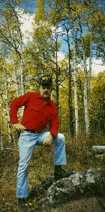
Mountain Man Mel
Mel Deweese, “Mountain Mel,” has more than 30 years of worldwide experience teaching survival skills. He is an internationally known and respected expert in nature awareness and survival techniques. “Our objective is a basic and simple one: To teach modern and selected primitive survival skills that are required to maintain life. Our motto is: Learn to Return.” As a military Survival Evasion Resistance Escape (SERE) Instructor (Retired Navy), he has created, developed, written, attended and taught courses from the Arctic Circle to the Canadian Wilderness, from the Philippine Jungles to the California desert. He has trained more than 100,000 students - civilians, Naval aviators, the elite SEAL teams, DEA personnel and students from other U.S. government agencies.
Click HERE to read this awesome bio about Mountain Mel!

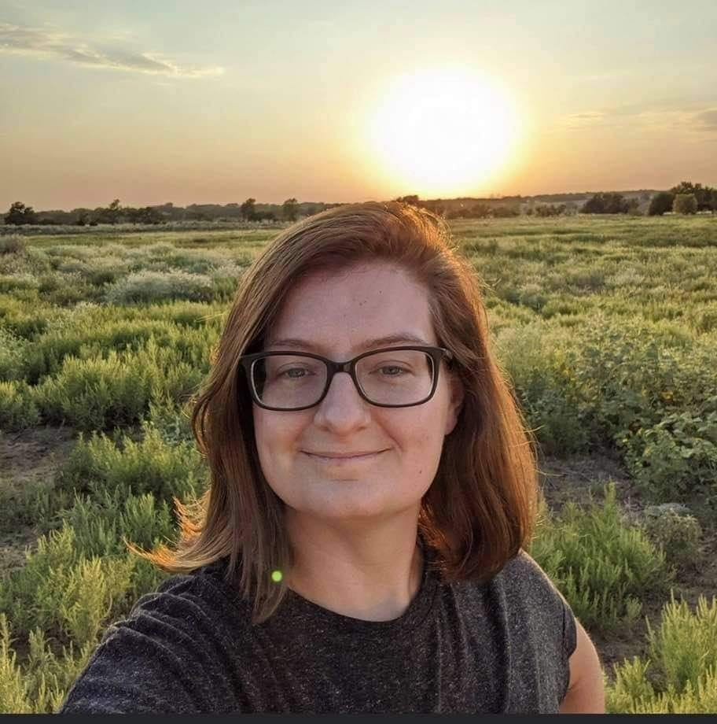
Nona Prather
Nona Prather was diagnosed as Type 1 Diabetic at the age of 10 in 1995. She grew up in a very active family. It came as a shock when she was diagnosed. There was no family history of Diabetes, so this was unknown territory. Nona's family encouraged her to be independent and take on the responsibility of the disease. Because of her family's support she has accomplished many things and is now a proud advocate for juvenile Diabetes research. Nona is also an author, business owner, wife and mother. She loves to snow ski, hike, kayak and ran a half marathon in 2015. She loves to encourage others to achieve their goals in life no matter what obstacles they may be facing.

IMPORTANT INFORMATION

In order for us to make this the best family camp for Families with Type 1 in the state, we need your help. We would ask you to have a “leave it better it better than you found it” attitude. We would also ask you to sign a liability release. That means you are responsible for yourselves with your own insurance at this camp. Parents, you are responsible for your children. If anyone is sick, hurt or in need of medical care we will have trained volunteer staff on duty. However, you will be responsible for the entire bill if emergency care is needed.

Practice the golden rule!! Grand Mesa Methodist Camp is a family camp that generally hosts church groups. Our group is one of the only non-religious groups that use the camp. Thus, we need to be mindful of their rules and requests. Please keep your hands to yourself and on your own things and practice the Golden Rule. We want to be invited back, not asked to leave for good. Also, we have families of every shape, size, and age that attend our family camp so please use clean language. Please limit smoking (of any kind) to locations away from general meeting areas or from inside cabins. Failure to abide by camp rules and requests may mean that we are all asked not to return, and the offending party will be asked to immediately leave the camp.

GUIDELINES

A refrigerator in the dining room will be available for insulin storage.
Please clearly label your insulin and any medication you keep in the refrigerator.

Packing List | Diabetic Supplies | Leave at Home
sleeping bag/twin sheets, pillow, water bottle, sunscreen, mosquito repellant, flashlight/head lamp, shower towels and personal care items, toiletries, camera,  shorts & long pants, sneakers, sandals, light jacket  **Optional: box fan | Pump and supplies, Blood Glucose meter,  BG Meter strips,  CGM and supplies, batteries, or chargers prescription medications, INSULIN  Carb snacks (low BGs) | No pepper spray or mace, firearms, pellet, BB, paintball, or airsoft guns, sling shots, knives, or any other kind of device used or perceived as a weapon.
Small folding pocket knives with a blade less than 2 ½ inches are okay.

Modest Clothes and Modest Behavior: All clothing worn at camp must be modest by the standards of camp staff.

Zero Tolerance: Use or possession of drugs, alcohol, tobacco products, pornography, firearms or potentially dangerous weapons of any kind, and other inappropriate material at camp will not be tolerated.

Quiet Camp: Please maintain a quiet camp atmosphere from 9:00 pm to 7:00 am.

CAMP DETAILS
Date: August 25-27, 2022
Location: Grand Mesa Methodist Camp 26269 Old Grand Mesa Rd, Cedaredge, CO 81413
Check in: 5:00-6:00pm on Friday the 25th
Check out: 10:30am on Sunday the 27th
Theme: Back to Nature

Deposit: There is a deposit of $100 required with your registration. This deposit is a safety for DCN that covers expenses in the event that you are unable to attend. We have to pay for shirts, craft supplies, and food all ahead of time.
Please note: We ask all families to consider donating their deposit back to Diabetes Counts Network after camp. This donation helps us ensure future events for your family. Participation in this donation after camp is optional.

*** Cards and check deposits are not processed until the week following camp. If you choose to have the deposit returned, your information simply won’t be processed. It will be shredded. If you wish to have your deposit donated back to DCN, it will be processed a week after camp.***

We will only accept family units with a minimum of a legal parent/guardian in attendance. All families must have an immediate family member with T1D to attend.

COMPLETING THE INFORMATION PACKET
- Review the Family Information Packet
- Complete the Family Profile and Supplemental Documents (pg 10-14)
- Include a $100.00 deposit
  - Checks to Community Hospital Foundation (note Diabetes Counts in memo).
  - Credit Card Information on the last page of this packet.
Please mail or deliver the Family Profile, and DEPOSIT, by Friday, August 4th to:
Grand Valley Wellness Center
c/o Sandy Paulson
605 B 28 ¼ Road
Grand Junction, Colorado 81506

OR please email the complete document to DiabetesCountsInfo@gmail.com
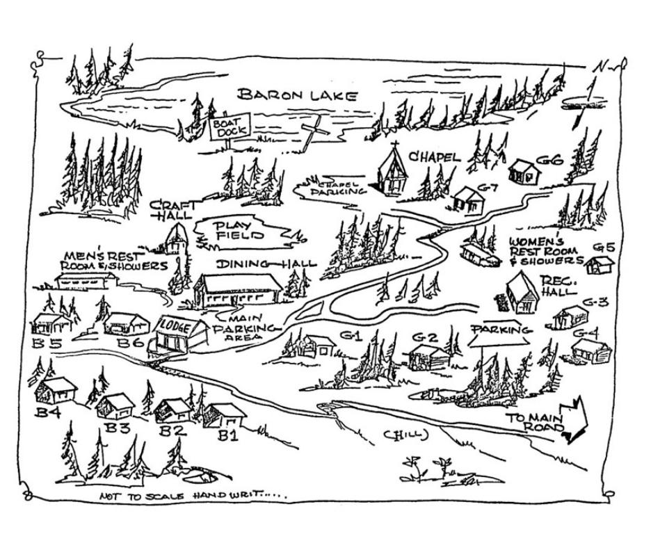

 |  | Camp 2023 Menu
Friday |  | Saturday |  | Sunday
 |  | Breakfast  8:30  SHARP | Scrambled Eggs  Link Sausage  Hash brown Triangles  mini bagels w/ cream cheese / gluten free toast option  cream cheese  gluten free toast  fruit bowl. Honey dew, cantaloupe,grapes | Breakfast  8:30  SHARP | Assorted cereal boxes/ gluten free cheerios  milks  sugar/sugar subs  Assorted muffins /gluten free muffins  Assorted 4 oz yogurts
Fruit Carb Info | Apple- 20g.  Orange- 10g  Cantaloupe- 7g= ½ cup  Honeydew- 7g= ½ cup | Lunch  1:00  SHARP | Pulled pork  Buns  gluten free buns  Bbq sauce  Baked beans  Coleslaw  coleslaw dressing
Dinner  6:15  SHARP | Lasagna/ gluten free lasagna  garlic knots or Gluten free french roll  spring mix salad with cucumbers and tomato  variety of dressings | Dinner  6:00  SHARP | Meatloaf  Mashed Potatoes  Gravy/ Gluten free gravy  Green Beans  Dinner Roll/ Gluten free roll with Butter | Salad Carb Info | Cheese 1 ounce = less than 1 gram carbohydrate  Carrots ¼ cup = 3 grams  Celery ¼ cup = 1 gram of  Cucumbers ¼ cup = 1 gram  Red Onion 1 Tablespoon = gram  Black Olives 4 olives = 1 gram  Pickles 5 slices = 1 gram  Jalapenos ¼ cup = 1 gram  Sunflower Seeds 1 Tablespoon = 2 grams  Lettuce 1 cup= 2 grams

Please Note Carb Counts will be provided at Camp

CAMP 2023 SCHEDULE

Friday – August 25
5:00- 6:00 pm Check-in Type 1 Families
Ongoing Explore Camp and Make Name Tag
6:00 Meet in Dining Hall- Welcome
6:15 SHARP Dinner Welcome
7:00 Camp Speaker 1: Brian Dalrymple
7:00 Movie “Open Season” and DIY Camp Bag Craft
8:00 Bon Fire and Classic Camp S’mores
Glow in the Dark Games
10:00pm Lights Out

Saturday – August 26
8:30 SHARP Breakfast Announcements
Ongoing Craft: DIY Birdhouse, Classic Camp Pin, Earn Camp Badges
9:30-11:00 Group A-1/2 Hiking, Geo Hunting, Zombie Apocalypse Survival with Don
Group B- 1/2 Crafts, Fishing, and Boating
11:00-12:45 Groups Switch Activities
1:00 Lunch with Eagle Riders
1:30 Camp Speaker 2: Sue Seserman
2:30 Camp Speaker 3: Mountain Mel Makes a Cool Treat 4:00 Free Time: Practice your Talent! Paint your Birdhouse, Fishing DIY Gelatin Bird Feeder, Photo paper art, Bead clip activity
6:00 Dinner
6:30 Talent Show
7:30 pm Camp Speaker 3: Fireside with Mountain Mel
10:00 Lights Out

Sunday – August 27
8:30 SHARP Breakfast and Camp Speaker 4: Nona Prather
9:15 Group Picture by Lake and Final Camp Badges
9:30- 10:30 Clean up Camp, Check Out and make Happy Trails Mix

FAMILY PROFILE
Please RETURN this 5-page form by Friday, August 4, 2023.
____ PLEASE MARK HERE IF YOU WANT TO BRING YOUR OWN TENT OR DRY CAMPER
____PLEASE MARK HERE IF YOU ARE WILLING TO SHARE A CABIN. _________________NAME OF FAMILY YOU WANT TO SHARE WITH ONLY IF NECESSARY

Shirts: Youth Small, Medium, Large and Adult Small, Medium, Large, XLarge, or XXLarge
Primary Point of Contact: ________________________________________________________
Name:_______________________________________________________________________
Email: _______________________________________________________________________
Cell Phone: ___________________________ Home Phone: __________________________
Address: ____________________________________________________________________
City: ______________________________ State: ________________ Zip Code: __________
Family Members Attending:
Name: _________________________ Name: __________________________
Age: __________ Gender___________ Age: _________Gender_____________
T Shirt Size_______________________ T Shirt Size _____________________
Is this person T1D: ________________ Is this person T1D: ________________
Name: _________________________ Name: ___________________________
Age: __________ Gender___________ Age: __________Gender____________
T Shirt Size_______________________ T Shirt Size_______________________
Is this person T1D: ________________ Is this person T1D: ________________
Name: _________________________ Name: ___________________________
Age: __________ Gender___________ Age: _________Gender_____________
T Shirt Size_______________________ T Shirt Size__________
Is this person T1D: ________________ Is this person T1D: ____

Please share with us more about your family:
Do you have a talent to share? Bring artwork or instruments to share during the talent show!! What will you be showcasing? So we can make proper preparations. ____________________________________________________________________________
What is your family hoping to gain from attending camp? ____________________________________________________________________________
Hobbies: ____________________________________________________________________
Sports: ______________________________________________________________________
Family’s favorite activity _________________________________________________________
Something special about your family _______________________________________________
If you HAVE been to Type 1 Family Camp:
Past favorite thing ________________________________________________________
Past least favorite thing ___________________________________________________
If you HAVE NOT been to Type 1 Family camp:
Most looking forward to ___________________________________________________
Least favorite thing _______________________________________________________
Does anyone in your family have any special concerns or needs? (Dietary, allergies, etc.)
____________________________________________________________________________
Does your family have any fears or concerns about being at camp?
____________________________________________________________________________
____________________________________________________________________________
Is there any other information you would like to share to help you have a great time at camp?
____________________________________________________________________________
____________________________________________________________________________
How did you hear about T1 Family camp? __________________________________________

Media Release Form – Minor
I , ____________________________________(parent/guardian), grant my permission for Diabetes Counts Network to use the name, likeness, image, voice, and/or appearance of
________________________________(minor), _______________________________ (minor),
________________________________(minor), ________________________________(minor) as such may be embodied in any pictures, photos, video, recordings, audiotapes, digital images, and the like, taken or made on behalf of Diabetes Counts Network. I agree that Diabetes Counts Network has complete ownership of such pictures, etc., including the entire copyright, and may use them for any purpose consistent with the mission of the Diabetes Counts. These uses include, but are not limited to illustrations, bulletins, exhibitions, videotapes, reprints, reproductions, publications, advertisements, and any promotional or educational materials in any medium now known or later developed, including the internet. I acknowledge that said minor will not receive any compensation, etc. for the use of such pictures, etc., and hereby release Diabetes Counts Network and its agents from any and all claims which arise out of or are in any way connected with such use.

_________________________________ I have read and understood this consent and release.

_________________________________ I give my consent to Diabetes Counts Network for the
aforementioned purposes.

____________________________________
Parent / Guardian Name

____________________________________ _____________________________________
Signature Date

____________________________________________________________________________ Minor’s Name & DOB

____________________________________________________________________________
Minor’s Name & DOB

____________________________________________________________________________
Minor’s Name & DOB
____________________________________________________________________________
Minor’s Name & DOB

CREDIT CARD FORM

Want to pay your deposit by credit card? Complete the following information below. We will file this form away in a secure deposit box until camp and shred the document once you attend. Please note we ask all families to consider donating their deposit back to Diabetes Counts Network. This donation helps us ensure future events for your family. Participation in this donation is optional, but you are required to still submit information for a deposit when you register.

** Cards and check deposits are not processed until after camp. If you choose to have the deposit returned, your information simply won’t be processed. It will be shredded. If you wish to have your deposit donated back to DCN, your check or card will be processed the week after camp***

Card Type: VISA MASTERCARD DISCOVER

Name on Card: _________________________________________

Card Numbers: _________________________________________

Expiration Date: __________________________

CVC Code on Back: _____________

Zip Code:__________________

